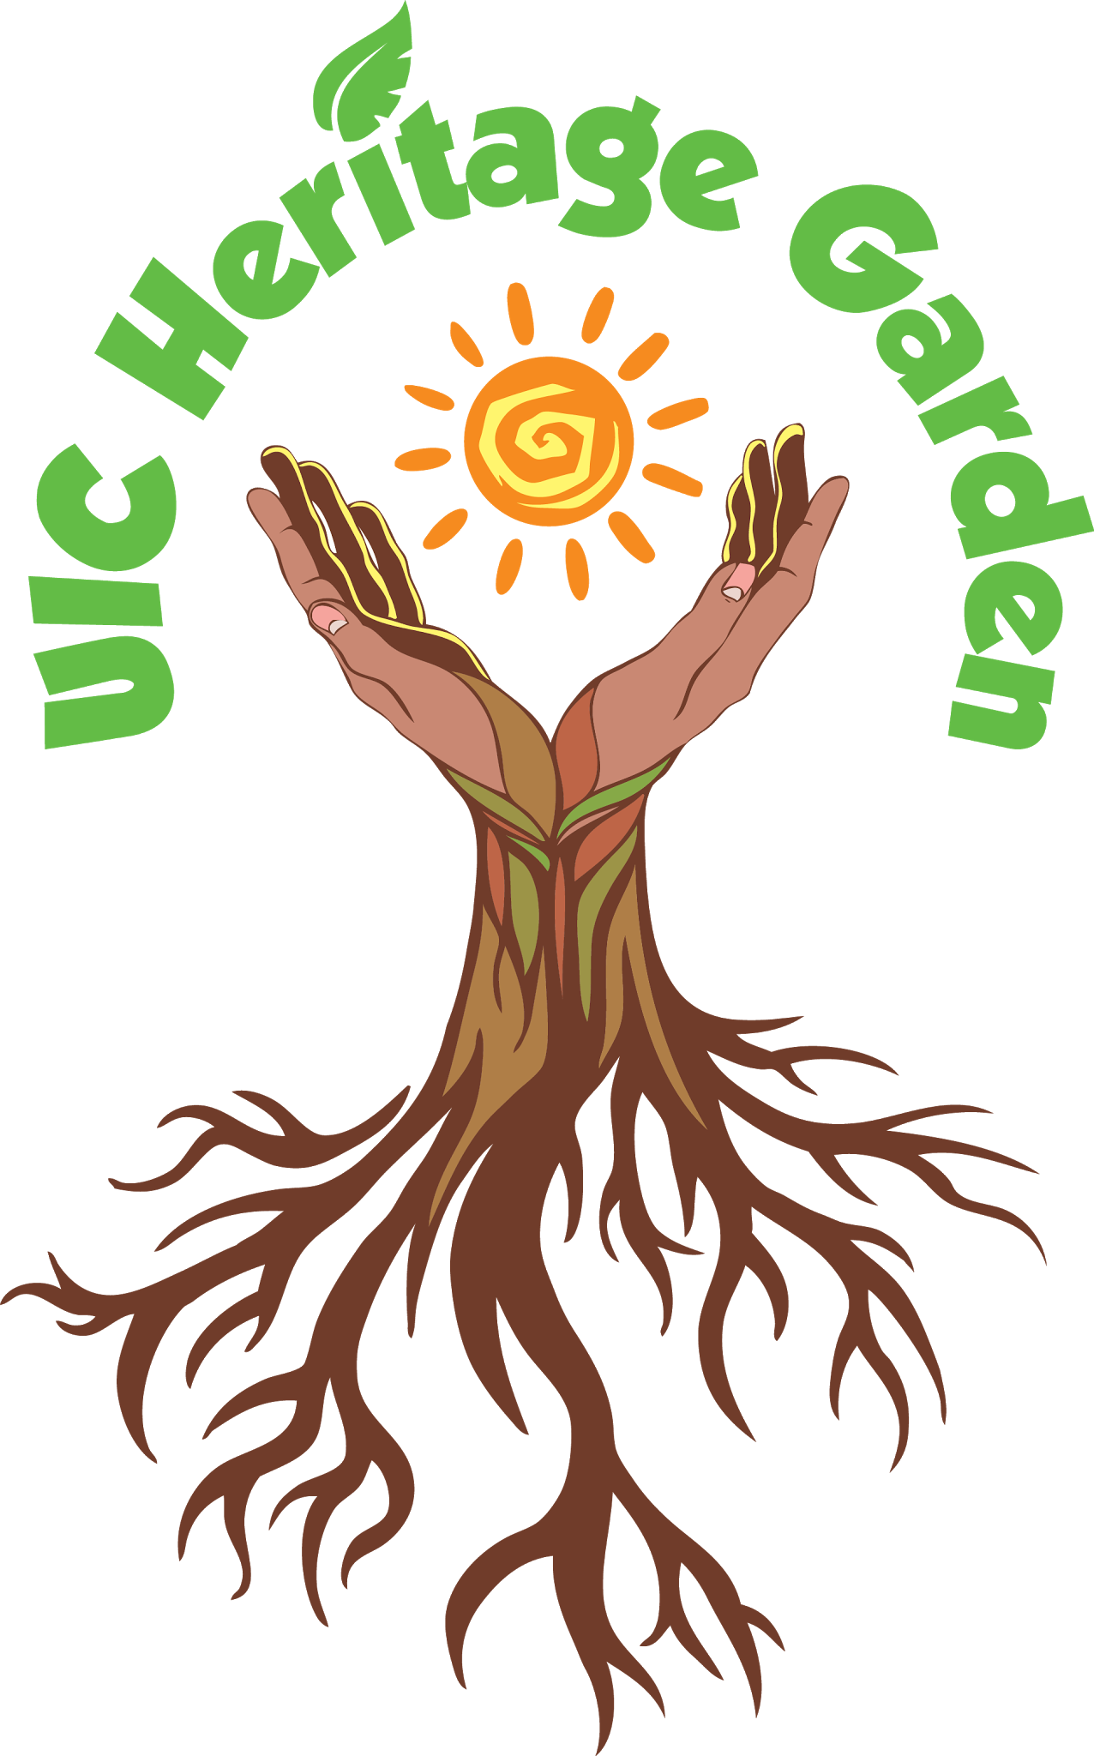
UIC Heritage Garden Summer 2017 Internship Application
Internship Program runs from
May 15 – August 11, 2017
With one week break July 3 – July 7
20 hours per week from 9am – 1pm
Monday through Friday
The UIC Heritage Garden Student Group is currently seeking upcoming Sophomore and Junior undergraduate students for the 2017 Summer Internship. The UIC Heritage Garden is a project of the seven Centers for Cultural Understanding and Social Change (CCUSC) and receives funding from the UIC Sustainability Fee. The goal of the UIC Heritage Garden is “to create an educational space to address quality of life that benefits both diverse people and nature.” Interns will assist with a variety of projects to support our goal. Interns will have the opportunity to continue with the UIC Heritage Garden through fall and spring semesters if they complete all aspects of the summer program in a satisfactory manner.
We are seeking responsible and committed students with excellent oral and written skills as well as the ability to work in a team and think creatively. Students with experience in the following areas will be highly considered: program development, communications, community outreach, research, social media, and a love for gardening. In addition, we highly encourage applicants with graphic design skills to apply. Interns will be paid a $2,400 stipend.
ELIGIBILITY
- Interns must be available to work 20 hours a week from 9am-1pm, Monday through Friday, beginning May 15 through August 11, with a week long break between July 3-7. If you cannot work during this time schedule or the full 12 weeks, then you will be ineligible for the internship.
- Interns must participate in ALL the activities outlined in the program syllabus. See syllabus on the UIC Heritage Garden website for the list of activities.
- Interns must have good academic standing, including a GPA of at least 2.5.
- The UIC Heritage Garden internship is eligible to DACA recipients.
Applications for the 2017 Summer Internships are due March 10th by 4pm. You need to turn in a typed hard copy of your application along with your resume attached to the Latino Cultural Center offices (lower level of LC B2).
On the week of March 27th, we will email a selected group of applicants to participate in individual interviews. These applicants will be expected to turn in a sealed letter of recommendation from a faculty member, advisor, or employer by Friday, April 14th at 4pm to the Latino Cultural Center offices. However, the letter of recommendation is not required for your initial application submission. The guidelines for the letter of recommendation will be provided through email correspondence on the week of March 27th.
If you have any questions about the internship and/or application, feel free to email us at heritagegarden.uic@gmail.com. For more information about the UIC Heritage Garden, visit our website: heritagegarden.uic.edu.

UIC Heritage Garden Summer 2017 Internship Application
Date ___________________
PERSONAL INFORMATION (please type)
Last Name _________________________ First Name _____________________________
Preferred Pronoun(s) ____________
Where will you live during the summer of 2017 (specify one)?
City of Chicago (specify neighborhood): ____________________
Suburb (specify):_____________________
Phone Number _______________________ UIC E-mail _______________________________
Major ___________________________ Minor______________________Current GPA_______

Anticipated Graduation Date (month/year): _______________

What is your cultural heritage(s)?
___________________________________________________
Have you previously been employed or volunteered in a garden setting?
___YES ___NO. If yes, when and where?

How did you find out about this internship program?
____ E-mail Announcement
____ Public Program
____ Website
Other (Specify): _______________________________________________________________
For the following section, please type out your responses for the short-essay questions, for a total length of two pages, single spaced.

- What skills and relevant experiences in the following areas - gardening, community engagement, research, program development, graphic design, and social media - do you bring to this internship? (~300 words)

- Have you observed any environmental/social injustices in your community or in current events? How would you work to fix them? (~300 words)

- Why do you want to participate in this internship and what do you hope to gain from it? (~300 words)

