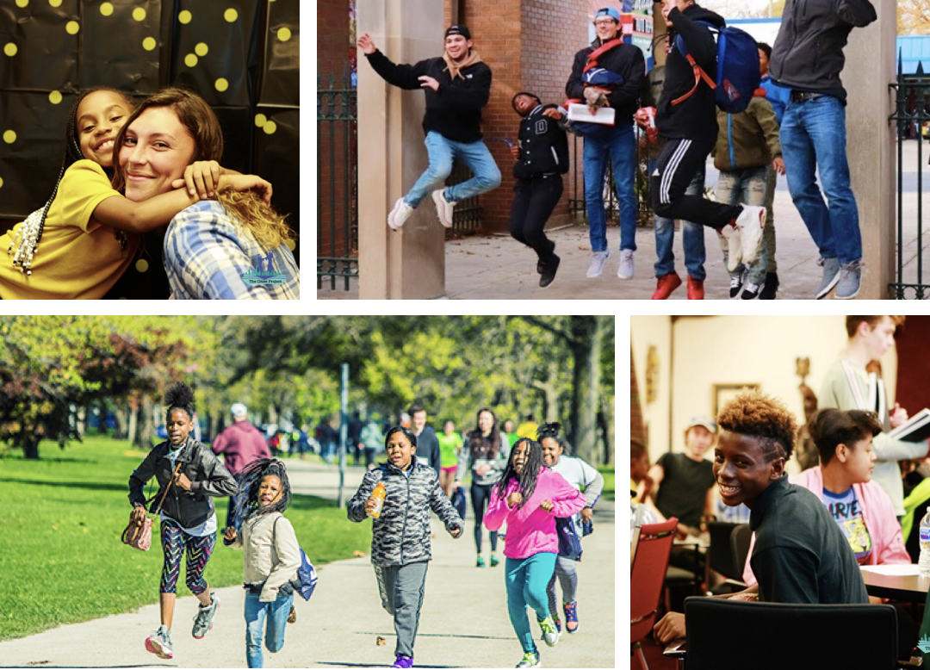
The UIC Cities Project
The Cities Project is a unique research and service project that has worked to enhance the lives of youth at Chicago Public Schools (CPS) since 2012.
UIC has a partnership with the Cities Project in which UIC undergraduate students will now have the exciting opportunity to participate and earn credit for their work. Each UIC student will be paired with a 6th-8th grade student to mentor at a participating school in the North Lawndale neighborhood. They will attend weekly mentoring sessions at their mentee's school throughout the 2023-2024 academic year in which they work in small groups as well as one-on-one with their mentee. This internship will provide students with the opportunity to develop skills for working with youth from diverse backgrounds. Please complete this interest form by using the blue QR code below, and we will reach out with application instructions. Email LPresc3@uic.edu with any questions.

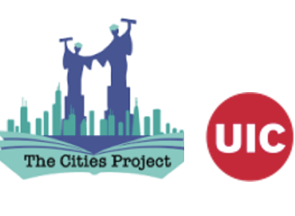 You can learn more about the Cities Project here:

