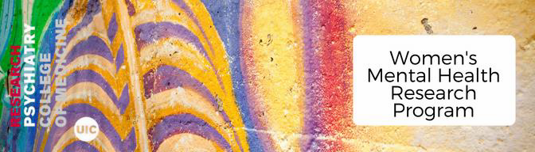

**APPLICATION FOR RESEARCH ASSISTANT (UNDERGRADUATE AND GRADUATE)**

Student Research Assistants are valuable members of the Women’s Mental Health Research team and play an important role in the implementation of our research studies. Students should be self-motivated and display a high attention to detail.

**Research Assistant Qualifications**

The student should be in good academic standing with a strong GPA (3.0 or above) and have an interest in women’s mental health, psychology, psychiatry, medicine, nursing, epidemiology, microbiome, biology, nutrition, immunology, computational biology, engineering or related field.

We strongly prefer a 2-year commitment from students because of the effort required to train students in our research methods. Exceptions may be made on a case-by-case basis for seniors. Students should plan to commit 10 hours per week during the school year to the WMHRP.

Preference may be given to students in the Honors College; students who have completed courses in research methods or statistics; and/or students with a background in biology, psychology, statistics, epidemiology and/or computer science/engineering. Familiarity with Excel and/or REDCap is ideal.

# Please return this application to [apaget2@uic.edu](mailto:apaget2@uic.edu), along with a copy of your resume and transcripts (unofficial copies are accepted).

**BASIC INFORMATION**

## Student Name:

UIN:

Email: Phone:

**ACADEMIC INFORMATION**

Class Standing: Honors College?

No

Freshman

Major: Major 2:

Minor: Minor 2:

Overall GPA*: Major GPA*:

*\*Applicants should submit a copy of their latest transcripts with this application (does not need to be an official version)*

## Estimated Graduation Date:

Are you interested in using this experience for academic/course credit?

**If yes, please provide further information on type of credit desired:**

Yes

Have you taken any Introduction to Research or Research Methods courses?

No

**If yes, please provide further information on course experience:**

Are you eligible for Federal Work Study?

Yes

## If offered a position in the WMHRP, when would you be able to start? Would you be able to commit to 2 years as an RA with the WMHRP? Are you able to dedicate 10 hours per week to the WMHRP?

No Unsure

Please provide the days of the week and times that you would be able to schedule shifts in WMHRP.

**Please note, all shifts should be a minimum of 2 hours. Available times are M-F, 7:30AM – 6:00PM.**

**Please provide a brief personal statement describing yourself, your academic and research interests, and any professional and/or career goals you may have. If you have not yet declared a major, tell us which fields you are considering and what factors could play a role in your final decision.**

**Why did you select the Women’s Mental Health Research Program?**

**Please describe the skills and talents you would bring to our team. Describe your strengths and weaknesses, especially as they apply to working in a group and/or academic setting.**

**If there is any additional information that you think would be important for us to know when considering your application, please provide that here.**