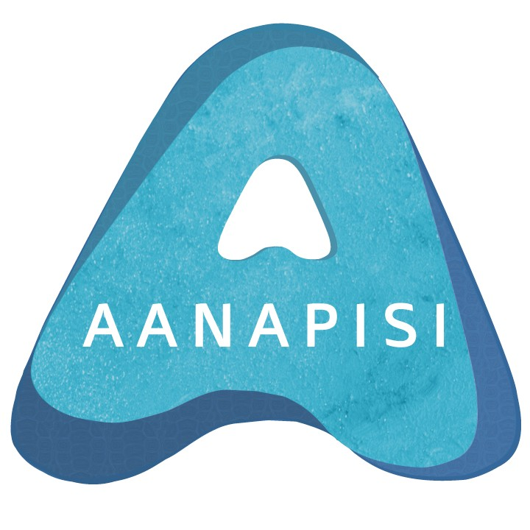

ASAM Expo Grants for Undergraduate Research and the Arts
2014-2015

Are you interested in doing independent research or a creative-arts project next semester? Need some funds to do so?

The UIC Asian American Studies Program is pleased to announce the ASAM Undergraduate Research / Arts Grants Program for 2014-2015. These competitive grants, of up to $1000, are designed to facilitate and encourage Asian American and Pacific Islander students to pursue independent research and/or creative-arts projects OR to facilitate projects by any undergraduate student focusing on Asian American or Pacific Islander topics. A total of up to ten grants will be awarded on a merit basis. Projects that have a Chicagoland and/or Midwest component will be prioritized in order to encourage local and community-engaged work.

Awardees will be supervised by a faculty mentor, and must demonstrate adequate progress to receive full funding. Awardees will be required to present their completed projects at the 2015 ASAM Expo Event in April to share their work with the broader UIC community.

Critical Research Grants
This grant provides funds for undergraduate students to develop original research beyond the bounds of the classroom.

Creative Arts Grants
This grant provides funding to assist students in completing substantial creative projects in the arts.

Eligibility:
Open to all currently enrolled UIC undergraduate students who are Asian American (with origins from East Asia, Southeast Asia, and South Asia) and/or Pacific Islander (with origins from Hawaii, Guam, Samoa, and other Pacific Islands).

Also open to any UIC undergraduate student regardless of ethnic background who is interested in pursuing a research or arts project with a focus on Asian Americans or Pacific Islanders.
Application Criteria

Eligible applicants should submit the following materials:

a) a short (less than 250 words) autobiographical statement, describing yourself and your work thus far; be sure to note your specific Asian American and/or Pacific Islander heritage (i.e., Sri Lankan-American), as well as any relevant publications / presentations / performances.

b) a short (250-300 word) project statement, describing your project's topic and timeline for completion

c) a sample of your work:

- for critical researchers: up to 10 pages of academic essay (typed, double- spaced); you may include multiple shorter essays, or one longer one; choose your best work

- for creative writers: up to 10 pages of poetry, 20 pages of drama, or up to10,000 words of fiction or creative nonfiction -- if sending a segment of a novel, novella, or novelette, please include a one-page synopsis as well.

- for visual artists: up to 10 slides / images, preferably sent as a link to a web page displaying the work; attachments are also acceptable

- for composers & musicians: up to 10 minutes of sample compositions / performances, preferably sent as a link to a web page displaying the work; attachments are also acceptable

- for actors & dancers: up to 10 minutes of sample performance, preferably sent as a link to a web page displaying the work; attachments are also acceptable

- please inquire if you work in a medium not covered above

d) please name an academic or professional reference who can speak to your ability to complete the project, with contact info (e-mail & phone)

e) a project budget (give examples of how you would use grant funds if awarded; for example, project supplies, recording materials, travel costs, time relieved from outside work, etc.)

f) you will need a UIC faculty member to serve as mentor for your project; if you have someone you would like to work with, please meet with them and confirm their willingness to serve as your mentor. If not, please contact Graduate Assistant Matthew Heichelbech (mheich2@uic.edu) so that he can assist you in finding a mentor before you submit your application. Please create an application cover letter with a signature from your mentor indicating that your mentor has reviewed your application, is willing to serve as your faculty mentor for the project, and that you have discussed any IRB requirements for your project. If IRB is required, the student will work with the faculty mentor to submit the proper IRB after grant notifications in mid-November.

Please Note: If awarded the grant, the recipient agrees to the following:
- provide a brief excerpt from their work, and an autobiographical statement describing themselves and their writing (250-500 words) for our files and for possible public dissemination on our website
- present their work at the annual Expo event in April 2015
- submit a four page reflection on the impact of the project toward future academic and professional goals at the conclusion of the grant
- acknowledge the UIC AANAPISI Initiative and the Asian American Studies Program on all publication and presentation that result from this work by using this blurb:

“This project was supported by a UIC ASAM Expo Grant supporting Undergraduate Research and the Arts in Asian American Studies. It is part of the UIC AANAPISI Initiative, fully funded by the U.S. Department of Education's Asian American and Native American Pacific Islander Serving Institutions program.”

*The student retains copyright to their work and is free to publish/produce it elsewhere

Application Procedures

1. Send the six items listed above to Graduate Assistant, Matthew Heichelbech (mheich2@uic.edu), in an attached Word .doc file, along with any supplementary sample work files. Please use the SUBJECT line: ASAM EXPO GRANT. Be sure to include your full name, UIC ID number, e-mail address, and phone number. If you have questions, direct them to that same address.

2. Applications must be received by November 3, 2014.

3. All applicants will be notified of the status of their application via e-mail by
November 17, 2014.

***

This program is sponsored by the UIC AANAPISI Initiative, which is fully funded by the U.S. Department of Education.

